# Advanced Software Engineering

## Assignment2

## Mobile Web Client Application

Student Details:

Sivakumar Pothala

16148142

Computer Science

# Report

Please click below link to view my work on mobile web client application.

Output link: <http://jsfiddle.net/shivapothala/8uczT/3/>

1. After running the code, Application looks like below screen

User enters the input by giving Source and Destination Locations and clicks on Submit button to view the Map

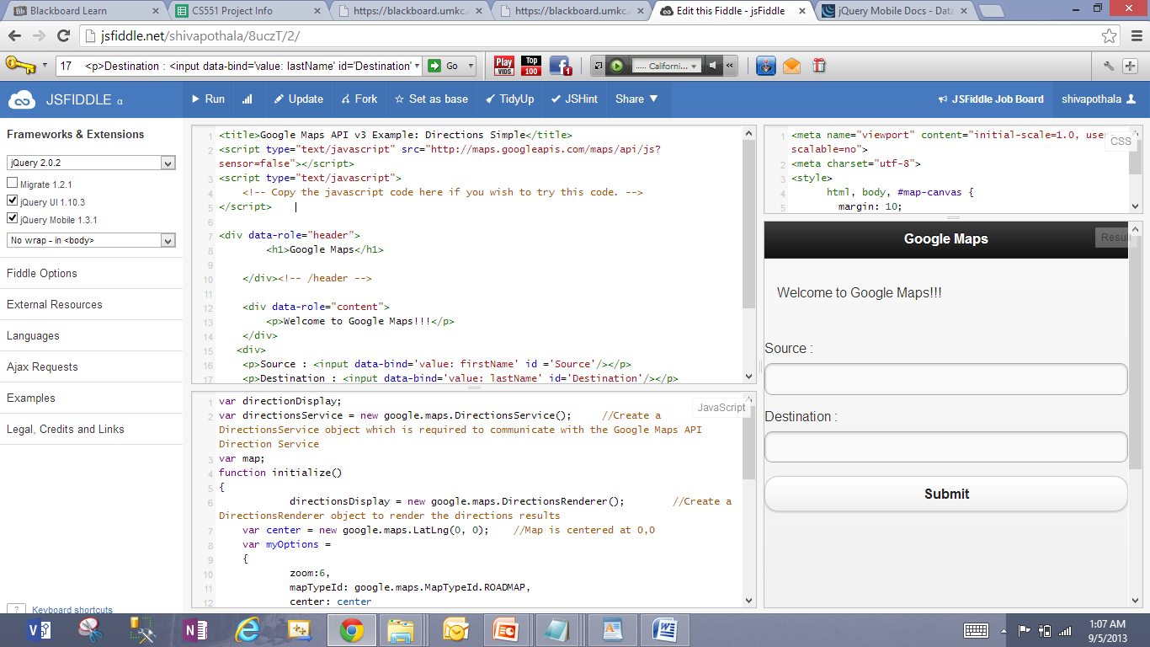

1. Map Display

Source: Kansas

Destination: New York

see the below output

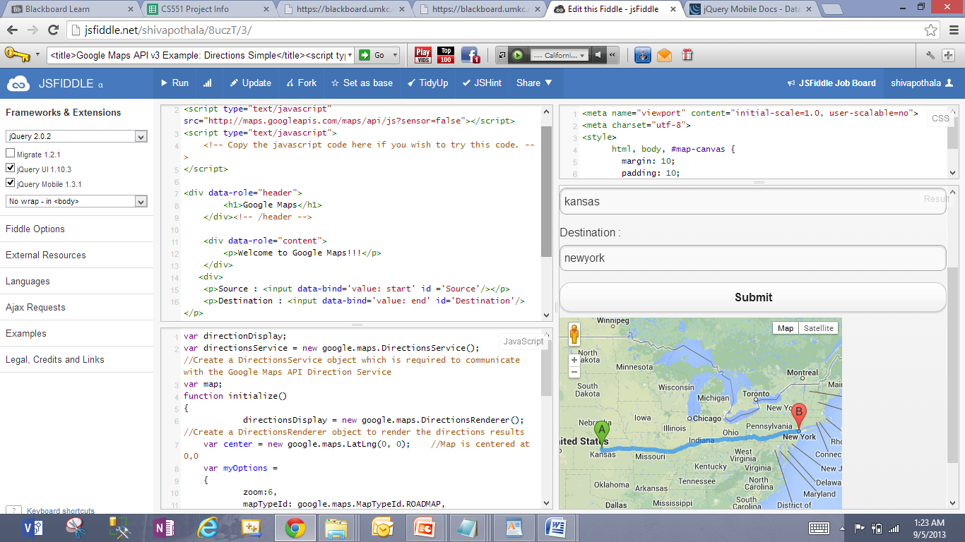

1. Map Display

Source: Texas

Destination: Florida

see the below output

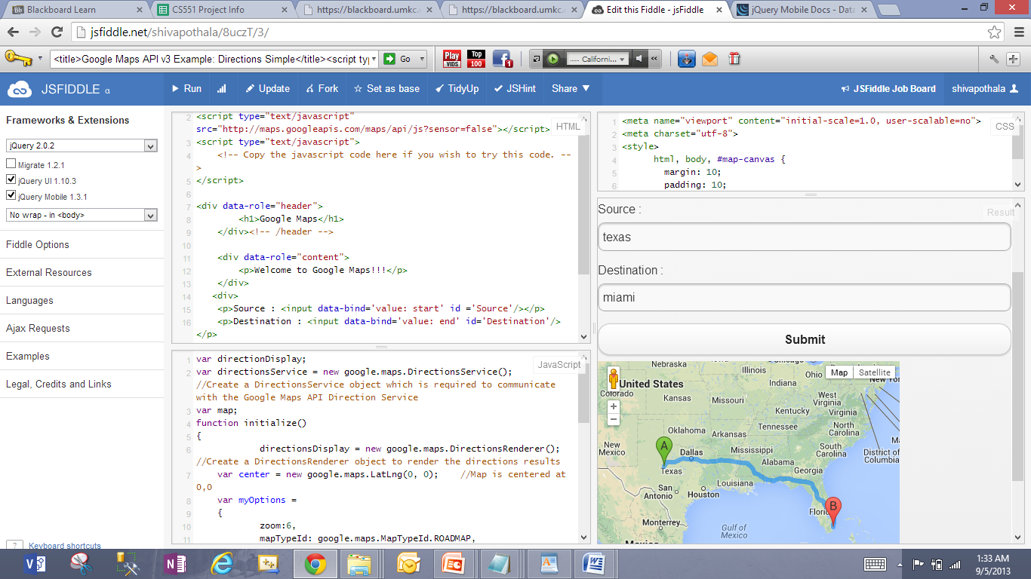

HTML code:

<title>Google Maps API v3 Example: Directions Simple</title>

<script type="text/javascript" src="http://maps.googleapis.com/maps/api/js?sensor=false"></script>

<script type="text/javascript">

<!-- Copy the javascript code here if you wish to try this code. -->

</script>

<div data-role="header">

<h1>Google Maps</h1>

</div><!-- /header -->

<div data-role="content">

<p>Welcome to Google Maps!!!</p>

</div>

<div>

<p>Source : <input data-bind='value: start' id ='Source'/></p>

<p>Destination : <input data-bind='value: end' id='Destination'/></p>

<input type = 'button' name = 'Submit' value = 'Submit' onclick = "initialize()"/>

</div>

<div id= "map_canvas" style="height: 350px; width: 400px"></div>

Javascript code:

var directionDisplay;

var directionsService = new google.maps.DirectionsService(); //Create a DirectionsService object which is required to communicate with the Google Maps API Direction Service

var map;

function initialize()

{

directionsDisplay = new google.maps.DirectionsRenderer(); //Create a DirectionsRenderer object to render the directions results

var center = new google.maps.LatLng(0, 0); //Map is centered at 0,0

var myOptions =

{

zoom:6,

mapTypeId: google.maps.MapTypeId.ROADMAP,

center: center

}

map = new google.maps.Map(document.getElementById("map_canvas"), myOptions);

directionsDisplay.setMap(map);

var start = document.getElementById("Source").value; //source

var end = document.getElementById("Destination").value; //destination

var request =

{

origin:start,

destination:end,

travelMode: google.maps.DirectionsTravelMode.DRIVING //Current travel mode is DRIVING. You can change to BICYCLING or WALKING and see the changes.

};

directionsService.route(request, function(response, status)

{

if (status == google.maps.DirectionsStatus.OK) //Check if request is successful.

{

directionsDisplay.setDirections(response); //Display the directions result

}

});

}

CSS code:

<meta name="viewport" content="initial-scale=1.0, user-scalable=no">

<meta charset="utf-8">

<style>

html, body, #map-canvas {

margin: 10;

padding: 10;

height: 100%;

}

</style>